DEPARTMENT OF BIOLOGICAL, CHEMICAL, AND PHYSICAL SCIENCE

ILLINOIS INSTITUTE OF TECHNOLOGY

PHYSICS 123

Atwood’s Machine

**Lab 5**

Markiyan Varhola

A20324717

Date of Experiment: Oct. 1, 2015

Due Date: Sep. 8, 2015

Lab Section: 03

Lab Partner: Bhav Bhalla

TA: Clay Contee

**Statement of Objective**

The object of this lab was to devise an experiment that would allow for the calculation of acceleration through the use of an Atwood machine. Also, the lab called for the calculation of the value of the gravitational constant using the Atwood machine, by devising an experiment to isolate the gravitational constant.

**Theory**

George Atwood created a device to make it easier to verify Newton’s laws of motion. By creating a system of a pulley and two masses, Atwood was able to observe an acceleration of both masses if they were not equal. The object with the higher mass would experience acceleration in the downward direction due to gravity, while the other object will experience acceleration upward by the tension of the string. In this system, the magnitude of the acceleration for both objects will be equal.

*Figure 1: An Atwood Machine*

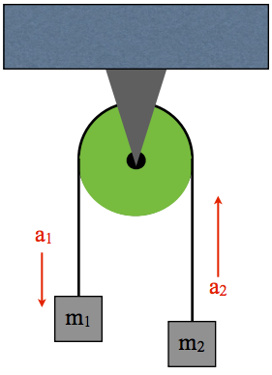

The forces in the system of the Atwood machine can be expressed using the following equation, assuming the mass of object 1 is greater than the mass of object 2.

*Equation 1: Forces on objects in the Atwood Machine*

$m_{1}a=m_{1}g-T$

$m_{2}a=T-m_{2}g$

The tension on both masses is equal, which means that when the acceleration is separated from the rest of the equations, the tensions cancel out. Therefore, the acceleration of the system can be determined from the following equation:

*Equation 2: Acceleration of objects in the Atwood Machine*

$a=\frac{(m_{1}-{m_{2})g}_{}}{m_{1}+m_{2}}$

The top part of the equation is the net force causing the system to accelerate, while the bottom part is the mass of the system.

**Equipment List**

* Smart Pulley
* Masses
* Rod
* Foam Block
* Ruler
* String
* **Safety Goggles**
* Data Studio Software

**Procedure**

A smart pulley was set up on the top of a rod, and was connected to Data Studio to monitor the acceleration experienced by the spin of the pulley wheel. A string was placed on the wheel, and two masses were placed on each end. For the first experiment, both masses were changed for each trial, and their acceleration recorded. For experiment 2, one mass was kept constant, while the other mass was changed in increments of 10 grams. The acceleration was recorded and used in calculating g.

**Data**

Experiment 1

*table 1: masses of the system, experimental and theoretical acceleration*

|  |  |  |  |  |  |
| --- | --- | --- | --- | --- | --- |
| **m1** | **m2** | **a (trial 1)** | **a (trial 2)** | **a (experimental avg)** | **a (theoretical)** |
| 100 | 120 | 0.84 | 0.84 | 0.84 | 0.89 |
| 95 | 125 | 1.27 | 1.25 | 1.26 | 1.34 |
| 75 | 145 | 2.95 | 2.96 | 2.96 | 3.12 |
| 70 | 150 | 3.35 | 3.34 | 3.35 | 3.57 |
| 60 | 160 | 4.24 | 4.21 | 4.23 | 4.46 |

Experiment 2

*table 2: masses of the system, their acceleration, and the calculated value of g*

|  |  |  |  |  |  |  |
| --- | --- | --- | --- | --- | --- | --- |
| **m1** | **m2** | **t** | **a (experimental)** | **a (theoretical)** | **(m1-m2)/(m1+m2)** | **g (slope of graph)** |
| 30 | 35 | 1.4 | 1.2 | 0.75 | -0.08 | -9.82 |
| 30 | 45 | 1.1 | 1.9 | 1.96 | -0.2 |  |
| 30 | 55 | 0.9 | 2.2 | 2.89 | -0.29 |  |
| 30 | 65 | 0.7 | 3.4 | 3.61 | -0.37 |  |
| 30 | 75 | 0.6 | 4.1 | 4.2 | -0.43 |  |
| 30 | 85 | 0.5 | 4.7 | 4.69 | -0.48 |  |

**Analysis of Data**

By using equation 2, and a value of (9.81) as the gravitational constant, the acceleration of the masses in the system was determined as *a (experimental).* The theoretical acceleration was compared to the measured value, and the following graph was produced.

*Graph 1: Theoretical Acceleration vs Experimental Acceleration*

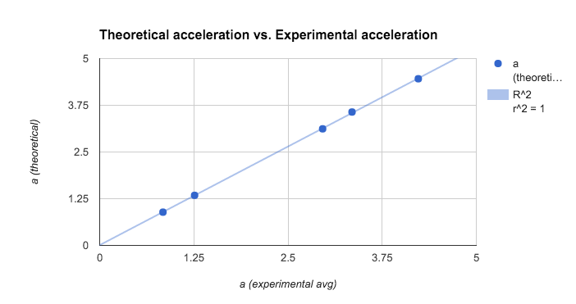

The R^2 value of the graph was very close to 1, meaning that the results were accurate compared to the theoretical values. In general, the actual experimental acceleration was slightly less than expected, due to factors such as friction and measurement accuracy.

The graph of force versus acceleration shows the relationship between mass and the rest of the system, as mass is the slope of the line.

*Table 3: Force vs Acceleration, Slope is close to total mass*

|  |  |  |
| --- | --- | --- |
| **a** | **force** | **Slope** |
| 0.84 | 196.2 | 232.1079613 |
| 1.26 | 294.3 |  |
| 2.96 | 686.7 |  |
| 3.35 | 784.8 |  |
| 4.23 | 981 |  |

*Graph 2: Force vs. Acceleration*

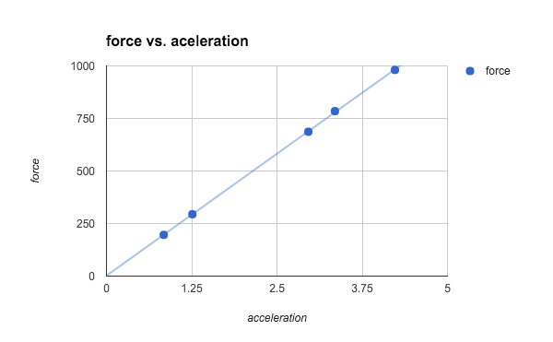

The second part of the experiment requires finding the value of the gravitational constant near the Earth’s surface. The value of the constant is seen as the slope in the following graph of Acceleration vs (m1-m2)/(m1+m2):

*Graph 3: Acceleration vs (m1-m2)/(m1+m2)*

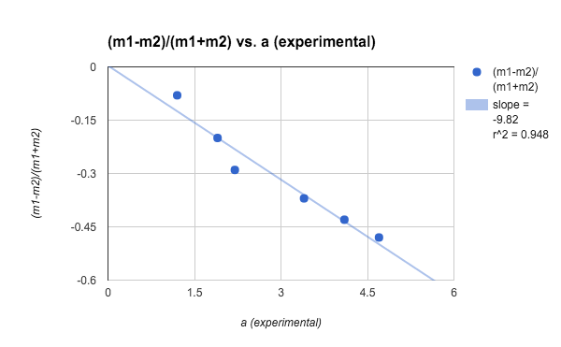

**Discussion of Results**

Part 1:

In data from part 1, there is a small discrepancy between the experimental value for the acceleration and the theoretical value, as the former is generally lower. This is probably because of the fact that some friction was present, possibly due to a misalignment, but an R^2 value that is extremely close to 1 shows that the accuracy of the measurements was high. The slope of the graph for Force vs. Acceleration was 232.10 grams, which was slightly higher than our measured value of 220 grams. It’s possible that the total mass of the system was 10 grams higher than measured due to variances in the weights. However, the mass is within 5% of the measured mass, therefore is fairly accurate.

Part 2:

The measured value of the slope of the graph represents the gravitational constant, g. The value obtained from this experiment is -9.82, which is very close to the actual value of 9.81. The value is negative as the acceleration was in the downwards direction, and the value of g is simply a magnitude, and not a vector, unless used in the right context.

There were several factors that could have caused errors in measurements, such as:

* The pulley and the string had mass (considered massless in true Atwood machine).
* The string could have stretched due to tension
* Friction was present in the pulley system
* Slight variations in the actual mass of weights vs the measured value.

**Conclusions**

The physics laws meant to be tested by an Atwood machine were supported by the results obtained from the experiments. Since the experimental data was very close to the

theoretical data, the experiment was done correctly, albeit with small sources of error.

**Questions**

*1. Calculate the tensions in the string for the second experiment.*

$T(m1) = mg-ma$

$T(m2) = mg+ma$

|  |  |  |  |  |
| --- | --- | --- | --- | --- |
| **m1** | **m2** | **a** | **T(m1)** | **T(m2)** |
| 30 | 35 | 0.75 | 271.8 | 369.6 |
| 30 | 45 | 1.96 | 235.5 | 529.65 |
| 30 | 55 | 2.89 | 207.6 | 698.5 |
| 30 | 65 | 3.61 | 186 | 872.3 |
| 30 | 75 | 4.2 | 168.3 | 1050.75 |
| 30 | 85 | 4.69 | 153.6 | 1232.5 |

As the second mass changes, the tension on the masses of both strings increases.

*2. What is the relationship between the acceleration and the total mass when the force is held constant?*

When the force is held constant, F/m = a => 1/m = a (for example), so as the mass increases, the acceleration decreases, as it is inversely proportional.

*3. How do these measurements compare with calculations using equation 3? What sources of error are most likely the cause of the discrepancies between your experimental data and your theoretical calculations? How well does the “ideal pulley” scenario hold? Explain.*

The experimental results are very similar to the calculated results using equation 3, however they tended to be slightly smaller due to factors such as the presence of friction and the accuracy of mass measurements. The ideal pulley in this scenario would require the pulley and the string to be massless and frictionless. Although the experimental pulley comes close, it is still not perfect, as it has mass and some friction.

**References**

1. Physics 123 lab manual, Experiment 5. http://science.iit.edu/sites/science/files/elements/phy/pdfs/2013_lab_123_5.pdf